3.12

Overnight

1. Spx rallied and closed at highs
2. SPX on Monday went up another 30 bps
3. VIX mar fut at 15.6, below end of Feb correction levels
4. NASDAQ already reached historical high again
5. SPX still 3% from highs at end of jan.
6. XU @ 0.9% premium (13700 vs 13580 cash)

Commentary:

Outside market is strong which supports continuing recovery.

Since today is Monday, still need to observe, and participate conservatively.

Charlie Munger’s speech on psychology

1. Don’t be the frog that fails to react to slow changes in temperature
2. Pay attention to disconfirming evidence
3. Envy affects us on a subconscious level. Identify when people do things out of envy

For tomorrow:

1. Clean up database, add 3/9 to database
2. Delete everything from chinavolsave first
3. Then load from excel file
4. Change identity start from 1.
5. Then at the end of each day, save in both excel and hib.

3.13.2018

1. highlight options that show their current day vol move.

Noon:

What was done:

1. Otm filter
2. Fixed bug: saving occurs before loading (when the program just opens)

What needs to be done:

1. Compare with last week/last month
2. Scroll through table, can see today’s intraday move AND which option it is (expiry and strike)

Expiry by color and strike by position in the graph

1. Click on a dot on the graph -> get the option ticker -> see intraday moves.

PM:

1. Vol up 2 days on a row.
2. Markets weak
3. Sell all bought delta at close.

Close:

1. Trading pnl -5k
2. Vol was up across the curve, should see this as a sign of instability and put on less position
3. Overall position management is good. Sold back the delta bought today
4. 1/3 delta worked well. Doesn’t cause stress. Was able to bring down position to opening delta at EOD.
5. Should not trade much when China vol/foreign vol is going up, volatility is contagious. China vol has been going up all day.
6. Tomorrow afternoon is tradable.

**3.14**

Open:

1. Markets in huge disagreement on XU.
2. First few minutes prices move around massively
3. Trade on massively drops within a time frame and disseminate promptly

10:30

1. Market sentiment: nervous
2. Vol: ATM 21.8, still uncertain
3. Skew: downside vols down, upside up +1.

After close:

1. Pm rebounded but fell back due to weakness
2. Put vols sold off (1 to 2v) and call vols were up slightly
3. Atm vol retreated by 1v

**3.15.2018**

1. US down overnight.
2. Vix at 17.2

**Vol Development:**

1. Compare with Multiple days (currently can only compare with ytd), compare with 7 days ago for example
2. Update frequency
3. 25D call and put lapse
4. 25P-25C skew change

Market:

On day trading (futures)

1. Small sizes per batch (1/3 max)
2. When batch is profitable, cut position actively
3. Trade more batches only if the previous batch made money
4. If no profit on the last batch, liquidate at close
5. Main use of futures is to hedge the AM and PM when there is no pm advantage
6. Long futures when pmclY-
7. Long futures when there is a big discount that can be exploited
8. Take advantage of random movements, not directional.

Day trading (stocks)

1. Aggregate position traded need to be less than current position
2. Long only
3. Sell back accumulated position at the end of the day
4. If the first batch fails, no additional batches (same as futures)

**After market:**

1. Atm front month -1v
2. Upside vols come off -1 ~ -2%
3. Longer dated vols off as well.
4. A50 closed at highest

**For future reference:**

1. Hedging will be the theme of trading
2. If hedging position is not making money, stop hedging ( this applies to bullish scenarios)
3. If hedging position is making money, keep taking profits and hedging
4. For stocks, always buy less than the current position and sell the current day’s bot position
5. For both stock and futures, use 1/3 of the position as day trading position
6. Keep taking profits on trading positions
7. If position is not making money, don’t add. Keep risk limited to 1/3.

3.16.2018

**Shorting rationale**

1. Index contains garbage stocks (shipbuilding, steel, iron etc)
2. Index underperforms solid earners in the long run
3. AM has no direction in general (sometimes trend pnl can be positive. When shorting position is not profitable, stop trading it)
4. When Am crashes, buy stocks, when AM goes up, hedge with futures.
5. Leave long exposure only when at a huge discount or PM is expected to rebound

**Shorting strategy**

1. Avoid trade clustering
2. Space trades out (trade every x minutes)
3. Hedge when previous day did not close at lowest percentile
4. Short at open (with big premium) and AM
5. Cover some at PM beginning – no advantage.
6. Short when market at intraday highs (no chasing)
7. Shorting should mirror buying in terms of strategies.

**When to short**

1. Previous trend pnl < 0
2. Volatility going up
3. When vol is in the high regime
4. Spaced entrance, enter during huge spikes
5. If consecutive positions are not making money, stop shorting, let long positions take over.
6. Crashes happen quickly and catch the market off guard.

**How much to short**

1. Cover long position

**When to trade long:**

1. Trade when T-1 was down
2. Trade when T-1 market closed in low percentile

Stocks ytd sharpe:

1. Banks underperforming index, bad targets for intraday trading
2. Moutai + Medea + pingan good for intraday

14:16

1. Markets made a move lower, vols started spiking
2. When markets can’t rally, there are always people taking profits
3. Any positive move will be sold off
4. Market is filled with greed and panic
5. Market goes up fast and drops fast
6. This requires good hedges.
7. If china closes poorly, that’ll affect the US, vol is likely to spike.
8. Keep short position overnight.
9. Shorting position worked out well today. Ytd closed at day highs. After the brief struggle in the morning, market crashed in PM.
10. Vols are now bid across the curve
11. Trading spreads is less stressful than trading pure directional delta.
12. Markets are based on short term trading behavior (gambling)
13. Chronically weaker than the US market.

After market:

1. Vol still high
2. Market crashed into close
3. Keep hedge on
4. Keep position roughly hedged
5. Trade both sides.

Weekend:

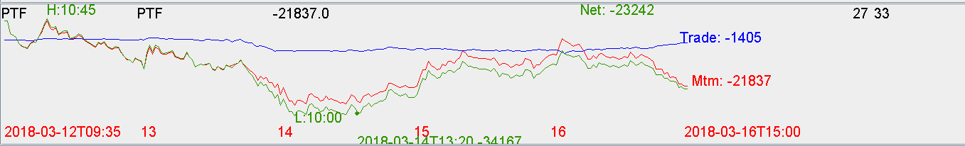

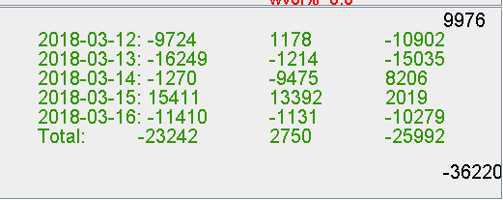

Commentary: this week ptf was down -20k. Good thing on Thursday started hedging the ptf with fut, previously was long only. Going forward, should always aim at hedging to reduce overall ptf volatility and increasing Sharpe. Short should be put on unless futures are at a big discount or fut has PM advantage.